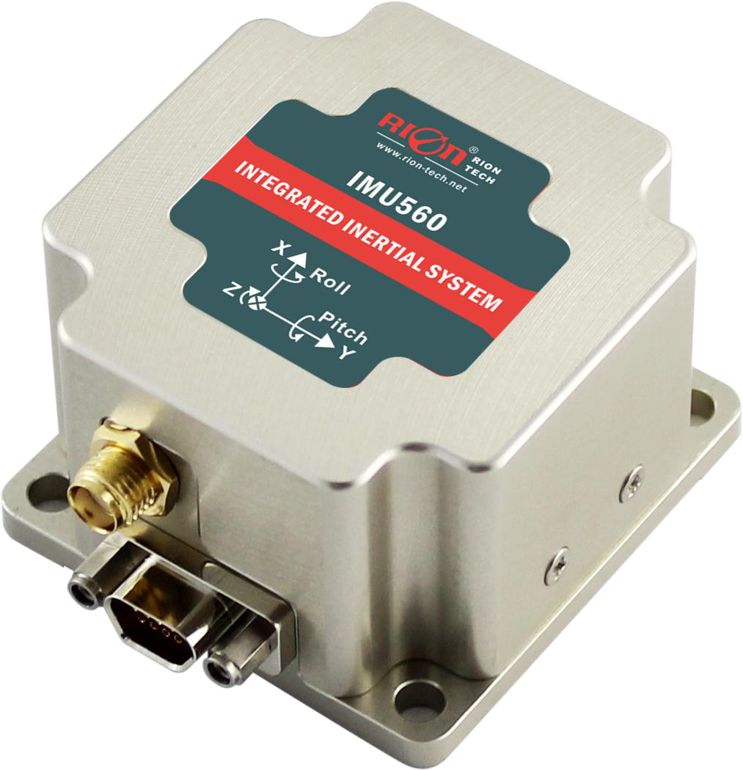

# IMU560 COMBINED INERTIAL NAVIGATION

# V2.0

# IMU COMBINED INERTIAL NAVIGATION

# Technical Manual



# IMU560 COMBINED INERTIAL NAVIGATION

# PRODUCTION EXECUTION STANDARD REFERENCE

○ Quality management system certification: GB/T19001-2016 idt ISO19001:2015 standard (Certificate

No.: 128101)

○ Quality management system certification: IATF16949: 2016 (Certificate No.: T178487)

○ GJB9001C-2017 Standard Weaponry Quality Management System Certification (Registration number:

02622J31799R0M)

○ Intellectual property management system certification: GB/T29490-2013 standard (Certificate No.:

41922IP00281-06R0M)

○ High-tech Enterprise (Certificate No.: GR201844204379)

○ ShenZhen Professional Dedicated Unique Innovative Enterprice(No.: SZ20210879)

○ CE certification:AT18250EC000560

○ RoSH certification: 18300RC20410801

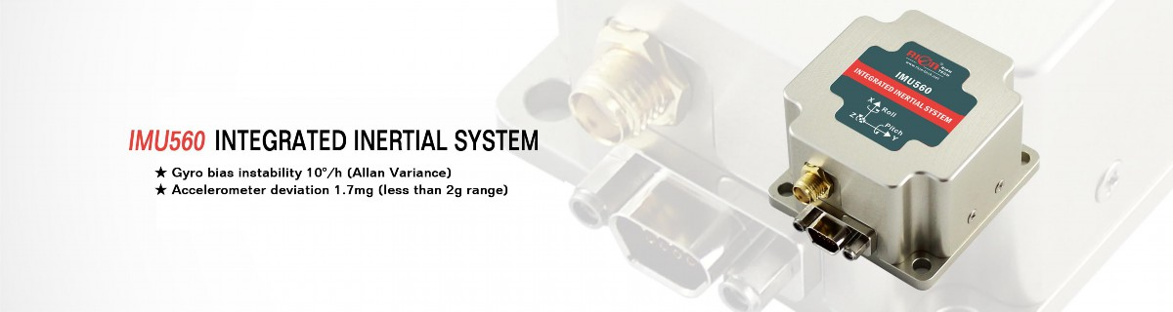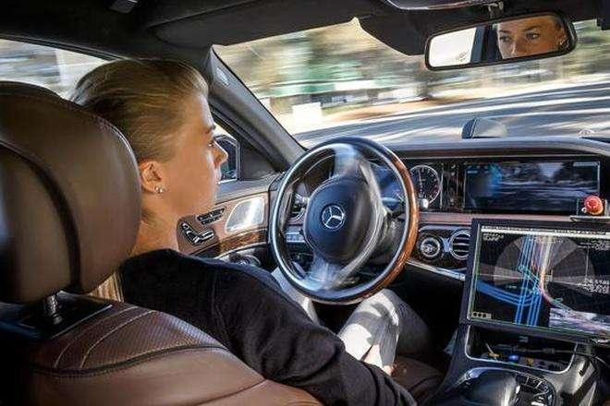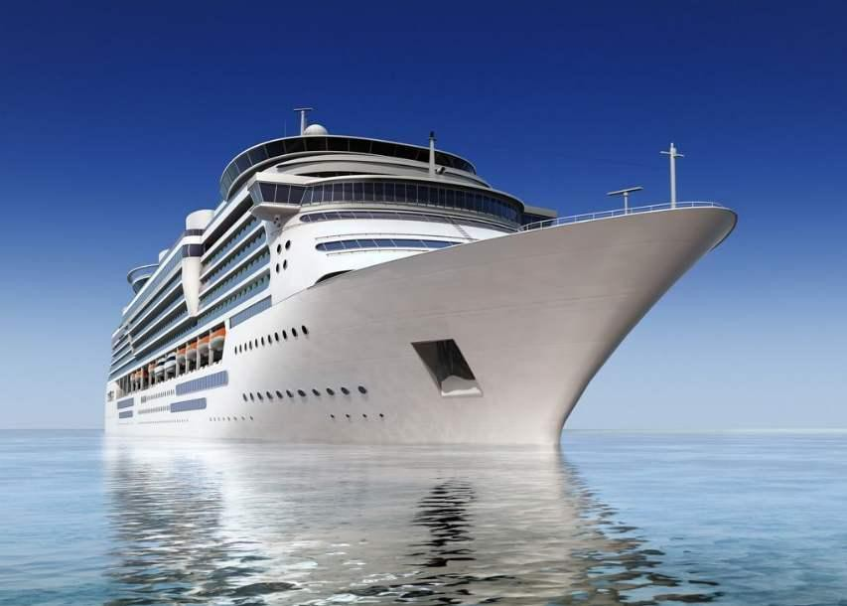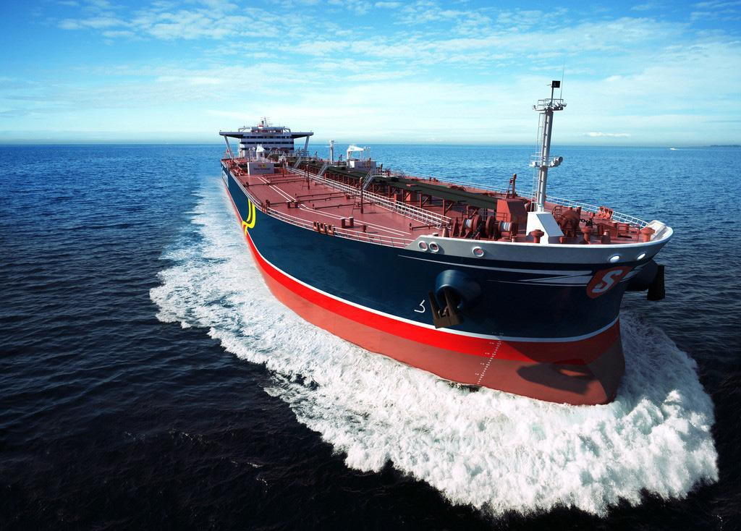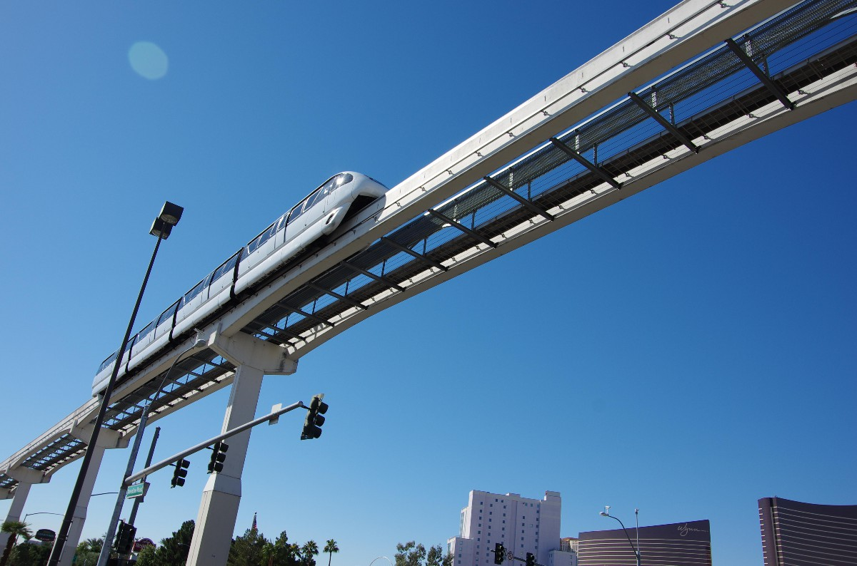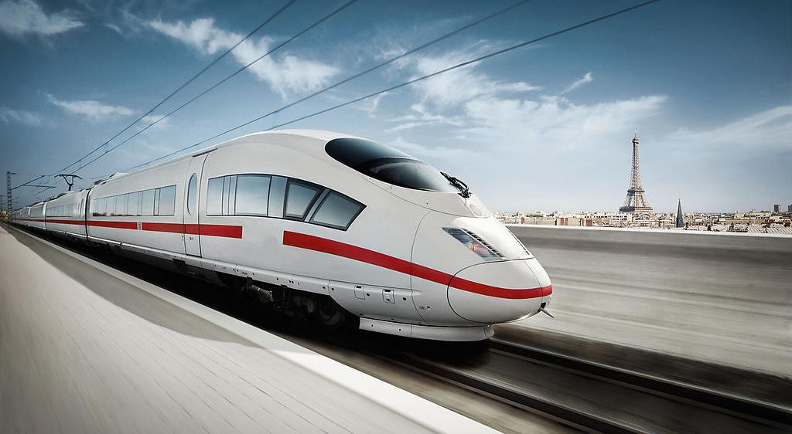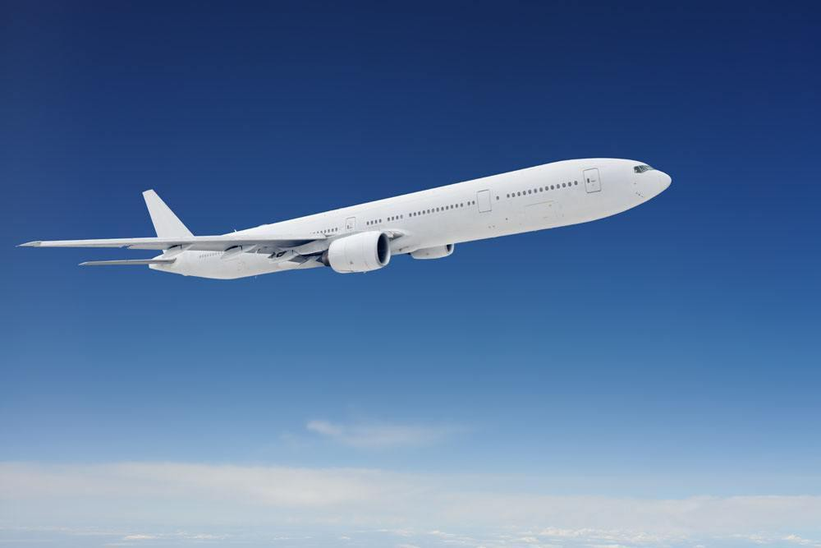

# IMU560 COMBINED INERTIAL NAVIGATION

# ▶ PRODUCT DESCRIPTION

The IMU560 series is a GPS/INS integrated navigation system built by RION.the inertial measurement

unit (IMU) is precision calibrated throughout the temperature range to meet performance requirements in

different environments. The multi-data Kalman filter fusion algorithm is realized by a built-in navigation

computer, and outputs real-time accurate carrier posture, heading information, three-dimensional

position and velocity information, and various inertial device information. The appearance is exquisite,

the structure is small, the installation is convenient, the use is flexible, and the operation is more stable

and reliable.

# ▶ PRODUCT POSITIONING

The IMU560 seriesis positioned as a vehicle/shipborne general inertial and integrated navigation product

target market:

(1) moving through

(2) Car navigation

(3) Dynamic attitude measurement

# ▶ PRODUCT FEATURES

# IMU560 COMBINED INERTIAL NAVIGATION

# ▶ SPECIFICATIONS

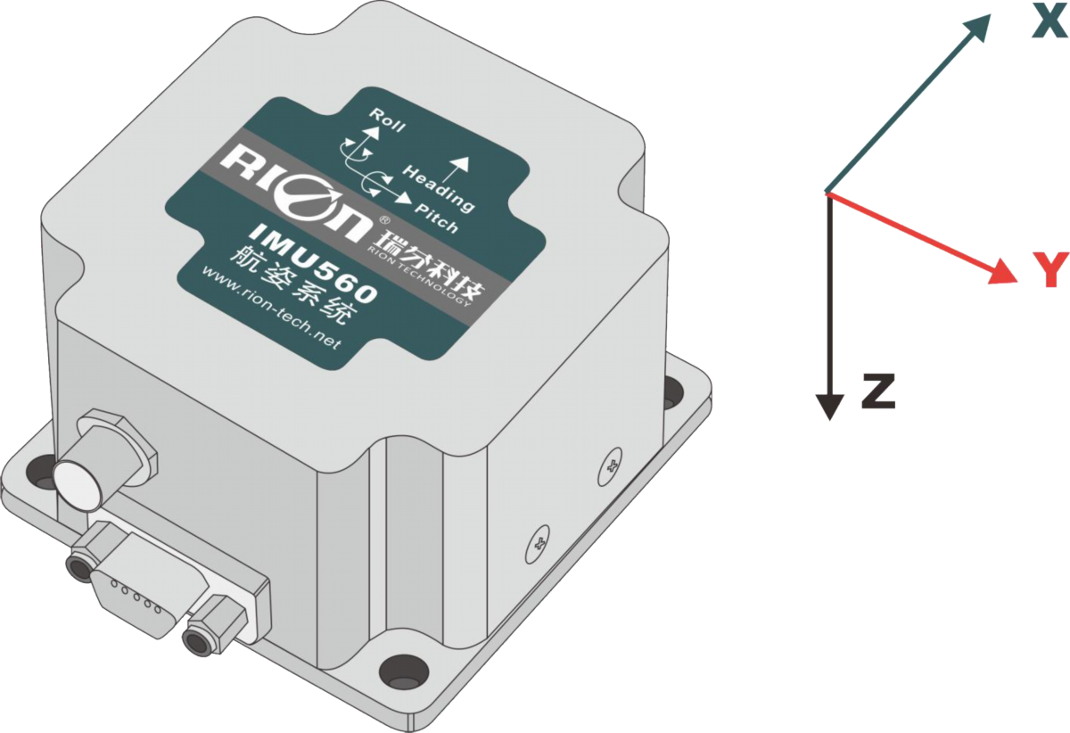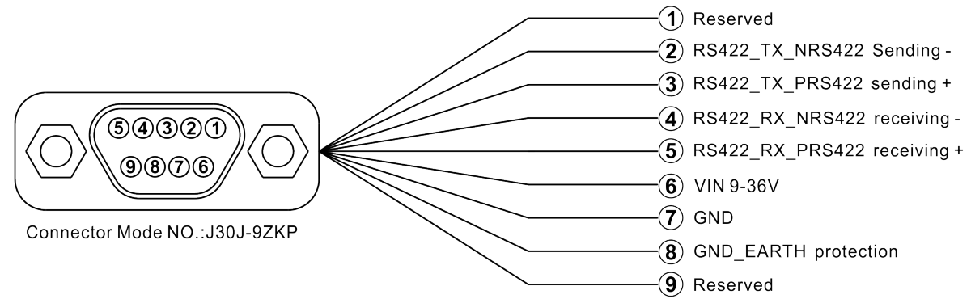

# IMU560 COMBINED INERTIAL NAVIGATION

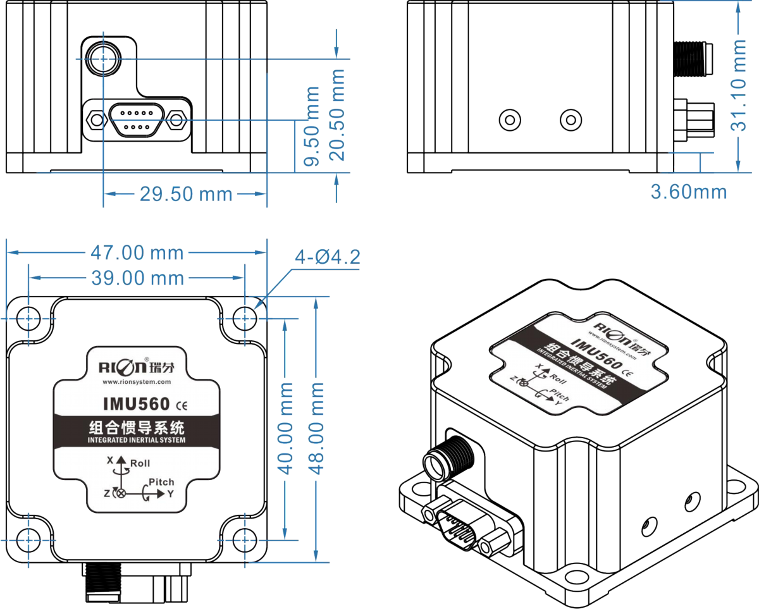

# IMU560 COMBINED INERTIAL NAVIGATION

# ▶ DIMENSION

Shell size：L47×W48×H31.1mm

Installation size：L39×W40×H3.6mm

Installation crews：4 M4 screws

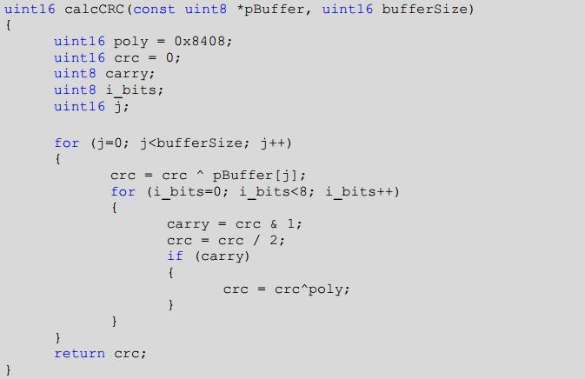

# IMU560 COMBINED INERTIAL NAVIGATION

# ▶ COMMUNICATING PROTOCOL

# 1. Communication frame format

# 1.1 Communication frame format

# IMU560 COMBINED INERTIAL NAVIGATION

# 2.1 normal mode

In normal mode, user send inquiry or setting command, the device response accordingly. The device

response has two formats: response (CMD=ASK) and reply (CMD=RET), for detail, please refer to

chapter 4 command list.

# 2.1.1 response

# IMU560 COMBINED INERTIAL NAVIGATION

# IMU560 COMBINED INERTIAL NAVIGATION

# 3.1.2 Sensor output after calibration

# IMU_OUTPUT_GYROSCOPES

3 axis gyro angular rate after calibration Gx, Gy and Gz, use real32(float) to indicate, 12 bytes, unit is

rad.S-1(radian/second).

Store format:

# IMU560 COMBINED INERTIAL NAVIGATION

# 3.1.6 Navigation output after Kalman filter compensation

# IMU_OUTPUT_POSITION

latitude, longitude and altitude, use real64(double) to indicate,

24 bytes, latitude and longitude unit is degree, altitude unit is m.

# IMU560 COMBINED INERTIAL NAVIGATION

# IMU560 COMBINED INERTIAL NAVIGATION

# IMU560 COMBINED INERTIAL NAVIGATION

# 4.1.2.2 Continuous mode

Used to query for continuous mode information, or to set continuous mode, mainly to set the output

working mode.

Mode can be used in two ways as follows:

IMU_NORMAL_MODE (normal working mode or called question and answer mode): 0x00

IMU_CONTINUOUS_MODE (continuous output mode): 0x01

# IMU560 COMBINED INERTIAL NAVIGATION

Eg2: Set to continuous output mode(100Hz):

TXD: FF 02 53 00 03 00 01 01 61 80 03

RXD: FF 02 01 00 01 00 05 63 03

# 4.1.2.2.2Acquiring continuous mode

* IMU_GET_CONTINUOUS_MODE------(0x54)

Function: used to read the current mode;

The frame format is as follows:

# IMU560 COMBINED INERTIAL NAVIGATION

Therein: DATApart

DATA

# IMU560 COMBINED INERTIAL NAVIGATION

# IMU560 COMBINED INERTIAL NAVIGATION

Therein: DATApart

DATA

# IMU560 COMBINED INERTIAL NAVIGATION

Note：Rotate the platform clockwise or counterclockwise, at least onerevolution, and the completed time

in more than 30 seconds.

# 4.1.5.1.1 Horizontal calibration start

# IMU_CALIB_MAG_START-----(0x08)

Function: Start horizontal calibration. After successfully executing this command, start to rotate the

platform.

# IMU560 COMBINED INERTIAL NAVIGATION

# IMU560 COMBINED INERTIAL NAVIGATION

# * IMU_RET_MAGNETIC_DECLINATION ------(0x42)

function：Returns the magnitude of the current gravity；

The frame format is as below:

# IMU560 COMBINED INERTIAL NAVIGATION

Function: Returns the default data item output.

The frame format is as below:

# IMU560 COMBINED INERTIAL NAVIGATION

The frame format is as below:

# IMU560 COMBINED INERTIAL NAVIGATION

total length: 0x0079):



# IMU560 COMBINED INERTIAL NAVIGATION

Add: Block 1 & Block 6, COFCO(FUAN) Robotics Industrial Park ,

Da Yang Road No. 90, Fuyong Distict, Shenzhen City, China